The problem:
You are pouring concrete for a slab at your house. It has the following shape:

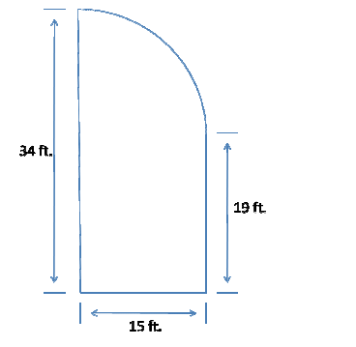

Concrete slabs are typically poured to 4 inches thick. Concrete must be ordered by the cubic yard, and you can only order it in 1/4-cubic yard increments. You have called the concrete delivery company, and received the following information:
Concrete costs:
- $101 per cubic yard
- Minimum of 2 cubic yards per order
Delivery fees:
- 2 to 3 3/4 cubic yards: $100
- 4 to 5 3/4 cubic yards: $65
- 6 yards and over: Free
Sales tax:
- The sales tax rate is 6.85%, and includes the cost of the concrete and any applicable delivery fee.

Part 1: Determining Volume
Use the information presented in the image above to calculate the volume (three dimensions: length, width, and height) of the concrete. It is often easiest to break the whole slab into separate shapes. Remember that you are looking for a three-dimensional object, and you want to make sure that all of your units are the same - don't try to combine feet with inches; instead, convert them both to the same unit: yards.
Be sure to include your work for finding the total volume of the concrete slab in your response.

Part 2: Determining Cost
Use the information presented above to determine the total cost of the concrete project. First, determine the amount of money that will be spent on just the concrete. Then, determine the delivery fee. Then, determine the sales tax that you will be charged. Finally, list the total price for the concrete.
Be sure to include your work for finding the total cost of the concrete slab in your response.

